**Shenzhen DaChengWei Electronics Technology Co.,Ltd**

**Company Profile**

Intelligent law enforcement equipment solution

**1.About Dachengwei**

Shenzhen Dachengwei Electronic Technology Co., Ltd. was founded in 2013 with a registered capital of 11 million yuan. It is a leading technology company specializing in mobile police equipment and 4G wireless transmission terminal products, integrating R&D, production, sales and after-sales service. A national high-tech enterprise, it has successively passed ISO9001, ISO14001, OHSAS18001, CCC, FCC, CE, ROHS and other certifications. In 2020, Dachengwei officially became an agreement supplier of the Ministry of Public Security.

The company mainly produces single police law enforcement video recorders, 5G/4G law enforcement recorders, data acquisition workstations, vehicle systems, 4G platforms, video lights, alcohol detectors, intelligent equipment cabinets, early warning sentinels, LED multi-function warning signs and other products. Law enforcement recorders and data collection workstations have been certified by the national Ministry of Public Security testing agency; Dachengwei has an efficient R&D team, a professional sales team, high-quality after-sales service, dust-free production workshops, strict testing standards, and has established nationwide coverage. The sales network provides more professional and convenient law enforcement equipment for law enforcement personnel. Public security, procuratorial, judicial, armed police, transportation, maritime, urban management, health, industry and commerce and other departments and foreign law enforcement personnel, adhering to the "customer-centric" principle, for Customers provide quality products and services.

On August 1, 2021, Shenzhen Well Electric Co., Ltd. and Shenzhen Dachengwei Electronic Technology Co., Ltd. officially merged. After the merger, it will fully integrate the advantageous resources of both parties, rapidly improve the comprehensive strength of R&D and production, and create more competitive and innovative software and hardware products and services. The new Weir and Dachengwei will go deep into the market, research and explore, shoulder the mission of the era of "made in China", strive to develop into a model for the new generation of technology manufacturing enterprises, and write a legendary chapter of the national brand!

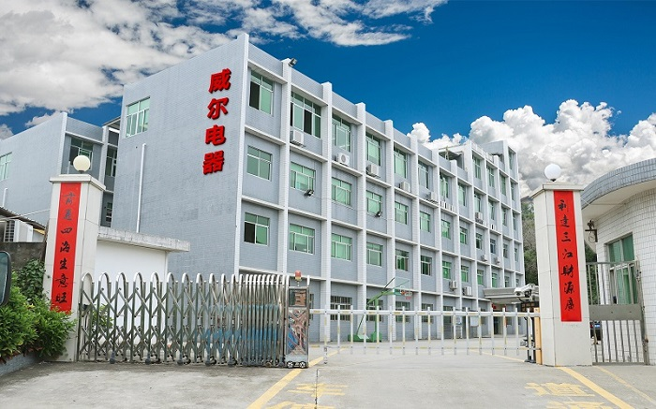

**2.Development path**

|  |  |
| --- | --- |
| January 2013 | Brand start-up |
| March 2014 | Passed ISO9001, ISO14001, OHSAS18001, AAA credit rating, CCC, FCC, CE, ROHS and other professional certifications |
| November 2016 | Won the national high-tech enterprise certification |
| March 2017 | The first to release 4G law enforcement products |
| April 2017 | Passed the national intellectual property system certification |
| May 2017 | Successfully developed iVS-100 smart city integrated management platform |
| May 2018 | Successfully developed face and license plate recognition intelligent body-worn recorder |
| June 2018 | Won the honorary title of "Contract-honoring and Credit-Reliable Enterprise" in Guangdong Province, and has successively obtained more than 30 patent certifications |
| September 2018 | iVS-100 Mobile Law Enforcement Integrated Management Platform, iDS-100 Electronic Evidence Integrated Management Platform Officially Launched |
| October 2018 | Passed the 5-star certification of the product after-sales service evaluation system |
| April 2019 | Dachengwei JD self-operated flagship store was officially established |
| June 2020 | Officially become an agreement supplier of the Ministry of Public Security |
| April 2021 | Officially settled in China Railway Group's "National Railway Mall" |
| August 2021 | Dachengwei and Well Electric officially merged |

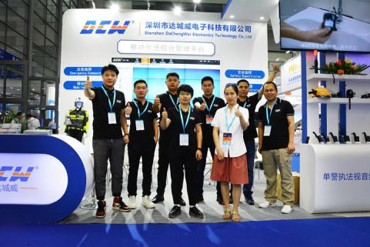

**3.Honor**

* National High-Tech Enterprise
* Intellectual Property Management System Certification
* ISO9001 quality management system certification
* ISO14001 Environmental Management System Certification
* OHSAS18001 Occupational Health and Safety Management System Certification
* 3A enterprise credit rating
* 5-star after-sales service certification
* 3C、ROHS、FC、CE Certification
* Enterprise of "Observing Contract and Valuing Credit" in Guangdong Province
* Information Security Management System Certification
* Radio Transmission Equipment Type Approval Certificate / Telecom Equipment Network Access License

Information security level protection: Level 2

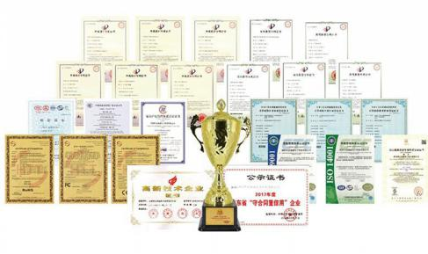

**4.Company advantage**

1. **R & D advantage**

* The company has obtained 21 appearance patents, 9 utility model patents and 13 software copyrights for a variety of products, and took the lead in developing the first 4G body camera in China, leading the industry in terms of innovation strength.；
* Highly educated and young professional R&D team, R&D positions account for 35% of the total number of employees, and R&D capital investment accounts for 8% of the total income；
* Face/license plate recognition, built-in 2.4G/5G Wifi, military/police private network 1.4G/1.8G communication, public security big data cloud platform and other new technologies are specially developed for the needs of various industries and have completely independent intellectual property rights.。

1. **Production advantage**

* The factory area is more than 10,000 square meters, with mold development workshop, injection molding workshop, automatic patch production line, automatic assembly production line, large cabinet equipment assembly workshop, and nearly 100 sets of various high-precision production and quality inspection equipment
* OEM cooperation with many well-known brands at home and abroad and online and offline, with annual shipments of more than 200,000 units

1. The professional production line of data collection workstations can customize various types of collection workstations such as vertical and portable for various industries and customers, and is compatible with all Dachengwei law enforcement recorder products, as well as mainstream law enforcement camera brands in the domestic market.

* **Quality advantage**
* More than 30 sets of high-precision inspection and testing equipment, 20 quality control teams, nearly 50 quality inspection processes;
* The production pass rate is 99%, and the repair rate of law enforcement equipment is less than 5%.

1. Project experience advantage

* Several units have successfully cooperated with customized solutions and have rich project experience;
* Dachengwei has a complete set of independent platforms, and the software and hardware can be seamlessly connected;
* With a highly specialized law enforcement recorder and collection station process control process, it can connect with various OEM cooperation.

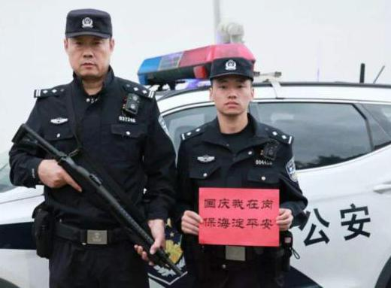**5.Success case**

**Police, traffic police, justice and other projects**

Beijing Municipal Public Security Bureau, Fuzhou Municipal Public Security Bureau, Guizhou Provincial Public Security Department, Qinghai Provincial Public Security Department, Chongqing Municipal Public Security Bureau, Wuhan Municipal Public Security Bureau, Qingdao Municipal Public Security Bureau, China Armed Police Corps, Jiangsu Provincial Prison Administration, etc.Pictured: DSJ-V6 body worn camera, Haidian Branch of Beijing Public Security Bureau.

1. **Business, taxation, forestry and other projects**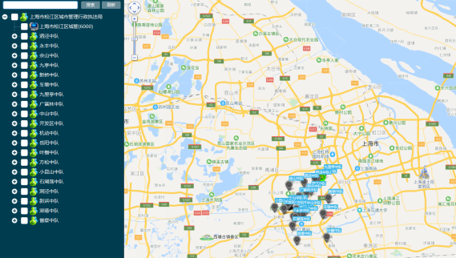

Shanghai Municipal Administration and Law Enforcement Bureau, Guangdong Provincial Forestry Department, Yunnan Provincial Taxation Bureau, Jiangsu Tobacco, Guizhou Tobacco, etc.Pictured: Shanghai Urban Management DSJ-V6 body worn camera, iVS-100 Mobile Law Enforcement Integrated Management Platform.

1. **Transportation, electricity, production and other projects**

* **Railway: Guangzhou Railway, Zhengzhou Railway, etc.**，Product：DSJ-D1、DSJ-D10、DSJ-V6 etc；
* **Electricity：**State Grid Beijing, State Grid Jilin, etc.，Product：DSJ-V6，D8 etc；
* **Airport：**Beijing Capital Airport, Hangzhou Xiaoshan Airport, etc.，Product：DSJ-V6 etc；
* **Other：**Sinopec, PetroChina, China Mobile, Jiangsu Productivity Promotion Center, etc.，Product：DSJ-D1、DSJ-V6、C1 docking station、D8、HD integrated PTZ camera.。

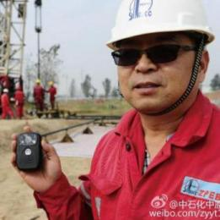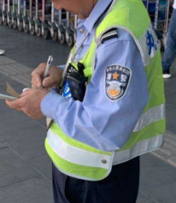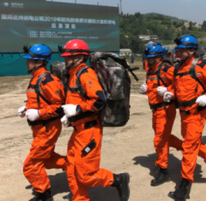

1. **Some OEM project cases**

|  |  |  |
| --- | --- | --- |
| HP A8 | HP A7 | DSJ-T6六视图  TCL T6 |
| 1574666667(1)  VOSNIC D7 | QIY | 采集站外观1-(22443)  China mobile |

**1.Service Introduction**

* **Full-time service: 365 days a year, 24-hour uninterrupted service, 2-hour emergency plan to support the after-sales of all products;**
* **National service: on-site service from offices across the country, support for various models of standby machines, and various remote technical support;**
* **Training service: For the supporting equipment related to the contract equipment purchased by the customer, our company will actively provide technical information that meets the equipment requirements, arrange special product R&D engineers with rich technical guidance experience, and provide a full range of technical training to ensure customers. Project equipment to achieve the best results.**
* **Customized service:：**
* **End Device Configuration：**Formulate terminal collocation plans, and comprehensively evaluate from various aspects such as model, quantity, function, collection, etc., to ensure cost optimization;
* **Industry differentiation：**Combined with the characteristics of the industry, a complete set of solutions can be customized to meet the needs of the industry environment from product adaptability and parameter limits;
* **Emergency control：**Focusing on major events, activities, etc., formulate targeted plans for emergency deployment and control.



**Leading to a New Era in Law Enforcement**

